Why am I getting a comfort pack?
The person you care for may have trouble breathing, anxiety, pain or discomfort, trouble sleeping, or nausea. These symptoms can be helped with medications. As symptoms can change quickly, it is important to have the medications ready to use right away.

These emergency medications will be in a sealed box and should be kept in the refrigerator. The medications should only be used if the physician or nurse from the Mount Sinai Palliative Care at Home directs you to open the box and use them. The medications should only be used for the patient. The physician or nurse will be on the phone (XXX-XXX-XXXX) or video chat to guide you on how to give the medications.

If your loved one is experiencing any symptoms, please call _________________________
(XXX)- XXX- XXXX

Instructions for Giving Medications Using a Syringe
The medications should only be used if the physician or nurse from the Mount Sinai Palliative Care at Home directs you to use them.
Liquid medicines are all given using a syringe like the one below. The syringe is placed in the patient’s mouth, and you drop the liquid either under the tongue or place it inside the cheek.

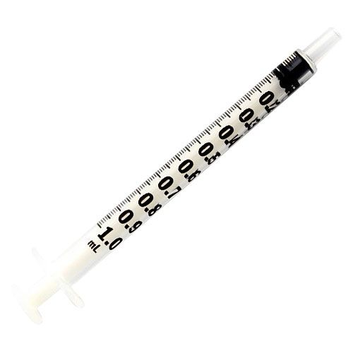

For difficulty breathing:
Give morphine: fill the syringe to the 0.3 mL mark and give under the patient’s tongue or inside the cheek. If no relief, repeat dose after 30 minutes.
If the patient is still breathless after 60 minutes, fill the syringe to the 0.3 mL mark with lorazepam and give under the patient’s tongue or inside the cheek – then call XXX-XXX-XXXX.
For pain:
Give morphine: fill the syringe to the 0.3 mL mark and give under the patient’s tongue or inside the cheek. Repeat after 30 minutes if no relief. Then call XXX-XXX-XXXX.
For anxiety, agitation, or restlessness:
Give morphine: fill the syringe to the 0.3 mL mark and give under the patient’s tongue or inside the cheek. Repeat after 30 minutes if no relief.
If the patient is still anxious, agitated or restless after 60 minutes, fill the syringe to the 0.3 mL mark with haloperidol and give under the patient’s tongue or inside the cheek –
If the patient is still anxious, agitated or restless after 90 minutes, fill the syringe to the 0.3 mL mark with lorazepam and give under the patient’s tongue or inside the cheek – then call XXX-XXX-XXXX.

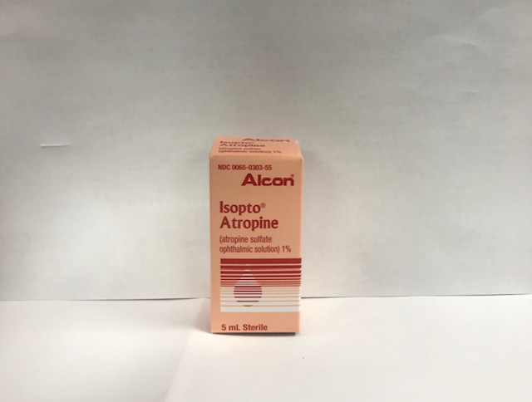
Medications in this pack include (box, vial, or dosage may be different than pictured here):

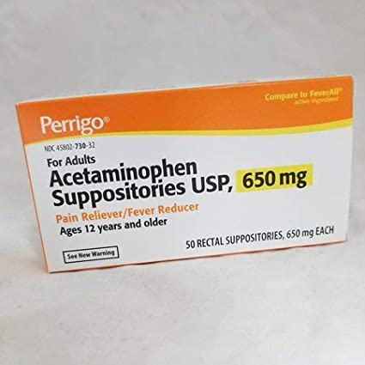
Acetaminophen (Tylenol) Suppository
- This is used for fever or mild pain if the patient
cannot swallow acetaminophen (Tylenol) as a pill
- Either give 2 regular strength acetaminophen (Tylenol) pills by mouth or one acetaminophen (Tylenol) suppository by rectum every 6 hours as needed for fever or mild pain

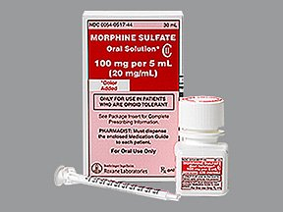
Morphine Solution
- This is used for shortness of breath or pain or cough
- Always use the oral syringe provided with the morphine to help make sure you measure the right amount (see instructions on the first page)

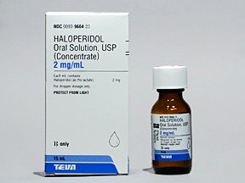
Haloperidol Solution
- This is used to help restlessness or confusion. It can also be used to help nausea
- Always use the oral syringe provided with the halperidol to help make sure you measure the right amount (see instructions on the first page)

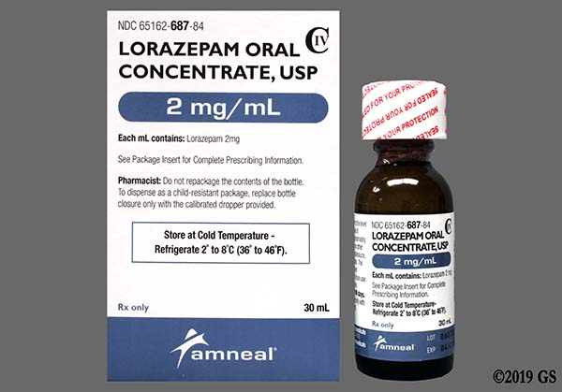
Lorazepam Solution
- This is used to help relieve restlessness or anxiety. It can also be used to help with nausea.
- Always use the oral syringe provided with the lorazepam to help make sure you measure the right amount (see instructions on the first page)

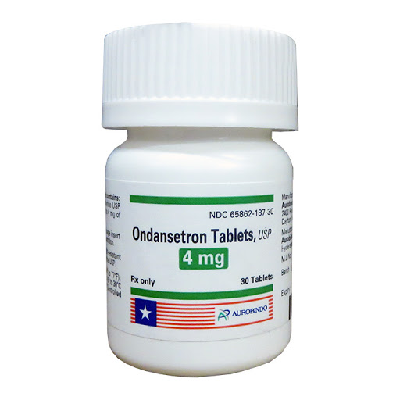
Ondansetron
- This is used to help relieve nausea or vomiting. The tablet dissolves in the mouth or under the tongue. Give one every 6 hours as needed. If no relief after 2 doses, call XXX-XXX-XXXX

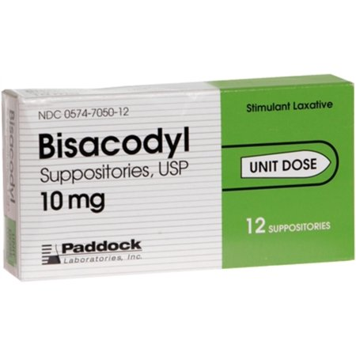
Bisacodyl (Dulcolax) Suppository
- This is used to relieve constipation. It is given as a suppository in the rectum every morning after breakfast. Can increase to 2 suppositories if needed. If no bowel movement after 2 days, call XXX-XXX-XXXX

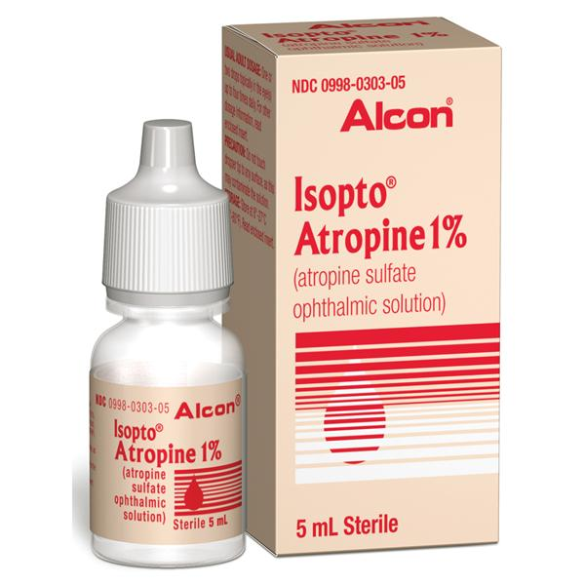
Atropine Solution
- Given under the tongue to dry up secretions in the mouth and throat. Use only if directed to do so by the doctor or nurse at XXX-XXX-XXXX.

