Background
Many states have legislatively-established Palliative Care Advisory Councils or similar bodies. These Councils are often charged with creating a palliative care education program, surveying the state for palliative care availability, and/or making recommendations to state policy officials on how to improve palliative care access for residents living with a serious illness. Many Councils are required to develop a report, although few are given a budget to do so; therefore, CAPC has developed the following report template for Councils or similar bodies to use. This template is primarily based on Nebraska’s most recent report, with inspiration from other states as well (please contact paymentandpolicy@capc.org for access to the State Palliative Care Forum, that includes other report examples).

Instructions
This template is most appropriate for Councils working on their initial reports, although any content can be used for subsequent as needed. It includes sample sections, verbiage, images, and figures that Councils may use, edit, or discard. Text that is red and bold (example) is intended to provide context and/or guidance, and should be removed prior to publication. Similarly, text that is italicized and highlighted ([example]) should be replaced with information that is specific to the Council’s state. For sample content that is used, please retain any relevant citations as well.

The template is lightly formatted with placeholders for title pages, section heads, etc. Canva is an online design and publishing tool that allows users to create a free account and has design templates that can help make the report more attractive. When drafting, designing, and finalizing, consider the following:
- Less is more – the shorter you can make your case, the more likely decision-makers are to read the report
- Allowing for plenty of “white space” in designed reports makes it easier for the audience to read and comprehend
- Don’t forget to include pictures!
- Once finalized, printing and hand-delivering the report (particularly to policymakers and/or their staff) significantly increases the likelihood that it will be read

Please contact paymentandpolicy@capc.org if you have questions on the template, or any suggestions for additional text, data sources, or other ways to improve the template.

TITLE PAGE [Insert State] Palliative Care and Quality of Life Advisory Council
Progress Report and Recommendations

Released [Insert Date]
[Insert any disclaimers; e.g., some Councils must state that opinions are their own and not necessarily endorsed by the association State Health Department. Please consult your Department as needed.]

Table of Contents
Simple table of contents to be customized once the report is drafted and formatted.

Palliative Care Case Studies

Palliative Care: [Case Study #1] p. X

Palliative Care: [Case Study #2] p. X

Executive Summary p. X

Introduction p. X

Council History and Charge p. X

The Current Palliative Care Landscape in [Insert State] p. X

Council Accomplishments p. X

Challenges in Expanding Palliative Care Access p. X

Recommendations p. X

Conclusion p. X

References p. X

Appendix A – Council Roster p. X

Appendix B – Historical Meeting Dates p. X

Appendix C – Glossary p. X

Palliative Care Case Study #1
Case studies are a powerful way to demonstrate how palliative care can improve quality of life for people living with serious illness and their loved ones. For these reports, it can be beneficial to identify patients and/or organizations in your state, as these may resonate better with state officials. Consider including a pediatric palliative care case study (which is often highly impactful, and can reinforce the message that palliative care is appropriate for all ages and stages of illness), and pay attention to diversity in race/ethnicity, geography, gender, etc. If needed, CAPC has many patient and family stories you can use, as long as these are attributed: https://soundcloud.com/get-palliative-care and https://getpalliativecare.org/blog/.

[Insert picture]

Paragraph #1 – Patient and family information: names, diagnoses, care in the “before” state; e.g., suffering from poorly managed symptoms, unnecessary utilization, etc.

Paragraph #2 – Sample of palliative care interventions

Paragraph #3 – Improvements in quality of care, quality of life as a result of the palliative care intervention

Patient/family names, location

Palliative Care Case Study #2

[Insert picture]

Paragraph #1 – Patient and family information: names, diagnoses, care in the “before” state; e.g., suffering from poorly managed symptoms, unnecessary utilization, etc.

Paragraph #2 – Sample of palliative care interventions

Paragraph #3 – Improvements in quality of care, quality of life as a result of the palliative care intervention

Patient/family names, location

Executive Summary
This should be a brief overview of key findings and what state official and other stakeholders should take from the report.

Palliative care is specialized medical care focused on relieving the symptoms and stress of a serious illness. It is appropriate at any age and at any stage, and can be delivered along with curative treatment. The goal is to improve quality of life.

The [insert state] Palliative Care and Quality of Life Advisory Council (Council) was established in [insert date] to [insert purpose; e.g., support public education on palliative care and make recommendations on ways to expand palliative care in the state].

This report provides an overview of the current palliative care landscape in [insert state], a recap of the Council’s activities and recommendations for moving forward. Highlights include:
- [Example – Insert finding on palliative care need and/or capacity]
- [Example – Insert key accomplishment]
- [Example – Insert key recommendation]

The Council would like to thank the following: [insert acknowledgements].

Finally, the Council would like to dedicate this report to [insert dedication, if desired].

Introduction
The goal of the introduction is to familiarize your audience with the definition of palliative care to avoid common misconceptions (particularly the tendency to conflate palliative care with hospice). It can also be beneficial to include the graphic on how palliative care ensures value, since the language of improving quality of life while reducing avoidable spending is likely to resonate with state officials.

Palliative care is specialized medical care for people living with a serious illness. This type of care is focused on providing relief from the symptoms and stress of the illness. The goal is to improve quality of life for both the patient and the family.

Palliative care is provided by a specially-trained team of doctors, nurses and other specialists who work together with a patient’s other doctors to provide an extra layer of support. Palliative care is based on the needs of the patient, not on the patient’s prognosis. It is appropriate at any age and at any stage in a serious illness (Figure 1), and it can be provided along with curative treatment.

There is a strong evidence base supporting that palliative care positively impacts health care quality, patient satisfaction, and care outcomes (Figure 2)., Furthermore, by matching care to patient’s goals and proactively addressing physical symptoms, it can help reduce avoidable and unwanted health care utilization (Figure 3).,,,,

Figure 1: Palliative Care in the Serious Illness Trajectory
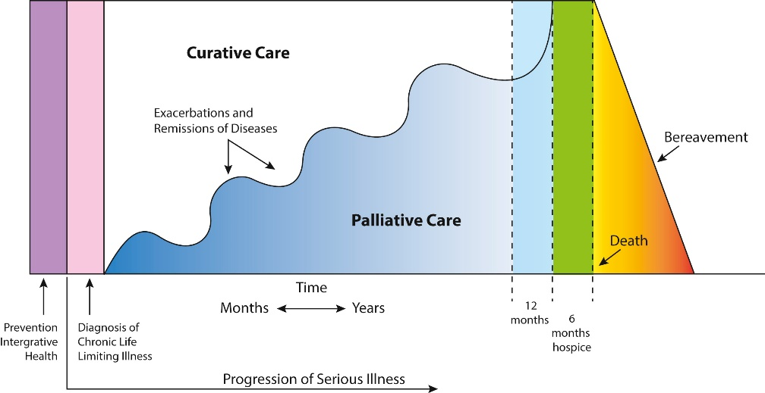
Source: Roth AR, Canedo AR (2019)

Figure 2: Palliative Care Impact on Quality of Life
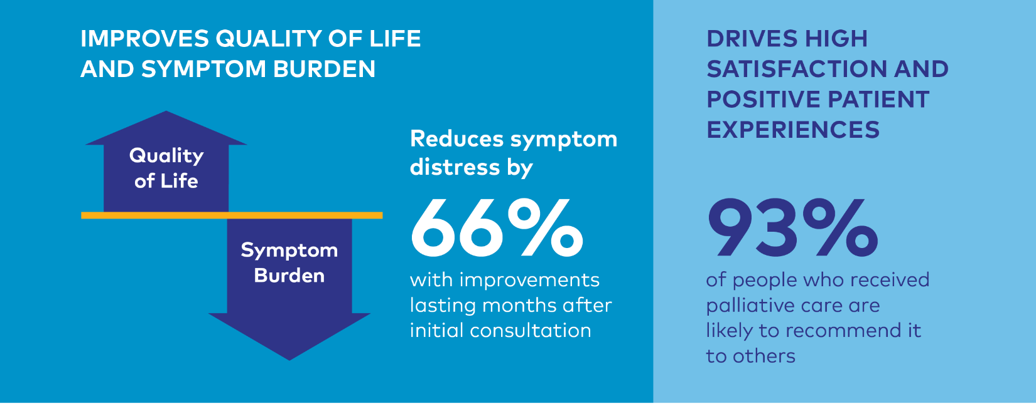
Source: Center to Advance Palliative Care

Figure 3: Palliative Care Impact on Health Care Utilization
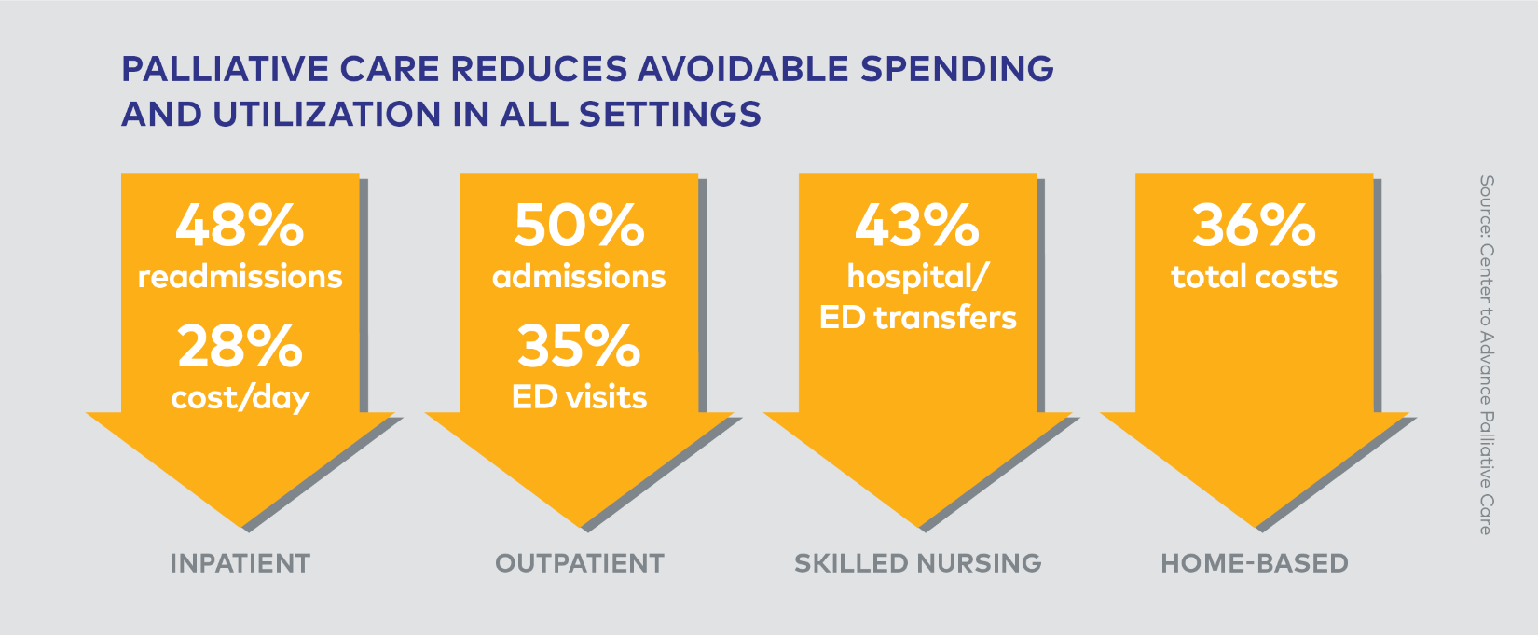
Source: Center to Advance Palliative Care

The Relationship between Palliative Care and Hospice
There is debate regarding the extent to which palliative care champions should mention hospice, since there is evidence to support that doing so can perpetuate misconceptions that palliative care is only appropriate for patients at the end of life. Nebraska’s Advisory Council decided to include the following section, since it helps position where each fall in the continuum of serious illness; however, other Councils should carefully consider how they want to approach the discussion. For best practices on messaging palliative care, visit https://www.capc.org/toolkits/marketing-and-messaging-palliative-care/.

There is often confusion between palliative care and hospice, particularly since both share the goal of providing support and comfort to people living with serious illness and their loved ones. The main difference is that palliative care is appropriate for all patients living with serious illness, regardless of whether they are expected to make a full recovery or eventually transition to end of life. Meanwhile, hospice is a specific type of palliative care that provides holistic, interdisciplinary care to patients who have a limited prognosis (e.g., the Medicare Hospice Benefit specifies a prognosis of six months or less). Hospice providers are expert in delivering end-of-life care, and hospices can provide a greater level of care than would be available earlier in the disease process with palliative care.

Ultimately, palliative care and hospice sit on the same continuum of care. When done well, palliative care can help improve quality of life during serious illness until the patient recovers (and into survivorship), or ease the transition to hospice when the disease becomes terminal. Please see the Glossary in Appendix C for more definitions.

Council History and Charge
The goal of this section is to establish your credibility for the intended audience. What is the Council’s authority and why is it issuing this report and/or making these recommendations? The following text describes the specifics of Nebraska’s Council; please make sure to replace with specific details from your Council/body.

In 2017, Nebraska Governor, Pete Ricketts signed the Palliative Care and Quality of Life Act (introduced by Senator Mark Kolterman as LB 323 in January 2017), Statute § 71-4501 through 71-4504, into law. The law established two entities:

The Palliative Care Consumer and Professional Information and Education Program, in which the Nebraska Department of Health and Human Services (NE DHHS) provides key palliative care information via its website, including:
- Continuing education opportunities regarding palliative care for health care professionals;
- Delivery of palliative care in the home and in the primary, secondary, and tertiary environments;
- Best practices in palliative care delivery;
- Educational materials for consumers of palliative care; and
- Referral information for palliative care.

The Palliative Care and Quality of Life Council (Council), which consults with and advises NE DHHS on matters relating to palliative care initiatives. The nine-member council includes physicians and nurses certified under the Hospice and Palliative Medicine Certification Program, administered by the American Board of Internal Medicine and other experienced palliative care professionals (see Appendix A for the Council Roster).

As the Council enters its fifth year (see Appendix B for a list of past meetings), this report provides an opportunity to share its progress and make recommendations for future work. The Council's goal is to ensure that all Nebraskans living with serious illness have access to high quality palliative care that will both improve their quality of life, and potentially reduce avoidable emergency department and hospital visits, as well as other unwanted care.

The Current Palliative Care Landscape in [Insert State]
Once it is clear how palliative care ensures value (included above), a compelling way to make the case for policy change is to share how many people in your state might need palliative care, and how many can currently be served. A few states have done in-depth analysis on their capacity (examples here); however, these can take significant resources to do well. The following section can be populated with available data.

Per The Commonwealth Fund (2017), approximately [insert number from The Commonwealth Report] percent of [insert state] aged 18+ living in the community were classified as “high need.” High need was defined as adults who have three or more chronic conditions, and a functional limitation in their ability to care for themselves or perform routine daily tasks. This definition largely intersects with the definition of “serious illness” used to determine palliative care eligibility; namely, “a health condition that carries a high risk of mortality AND either negatively impacts a person's daily function or quality of life, OR excessively strains their caregivers.” Examples include (but are not limited to) cancer, congestive heart failure (CHF), or chronic obstructive pulmonary disease (COPD).

At the national level, there has been dramatic growth in the availability of hospital-based palliative care over the last 20 years. [Insert state] received a [insert grade from the State-by-State Report Card] on the 2019 State-by-State Report Card on Access to Quality Palliative Care. [Insert context for what this grade actually means, particularly limitations; this blog provides a good starting point.] Additionally, there are significant disparities in access to palliative care based on geography, with the majority of palliative care services concentrated in [insert relevant cities].

Table 1: Hospital Palliative Care in [Insert State]
[Insert table from relevant individual state report]
* Grade does not include hospitals with <50 beds

Figure 4: Percentage of [Insert State] Hospitals with a Palliative Care Program by Geographic Type
[Insert figure from relevant individual state report]

The State-by-State Report Card also emphasizes that – across the country – there are disparities in access based on geography and hospital size. Furthermore, community-based palliative care remains limited, with only a handful of programs reporting home-based palliative care in [insert number] counties ([specify counties]). Finally, the Center to Advance Palliative Care (CAPC) reports that there are [insert number] certified prescribing palliative care providers (MDs or APRNs) per 100,000 residents in [insert state].

Nationally, it is it is estimated that approximately 5% of people who need palliative care receive it. Referencing the data above, it is clear that Nebraska has room to grow to ensure sufficient palliative care access for all residents living with serious illness.

Council Accomplishments
This will be the historical record of what your Council has done in the period covered in this report. Describing your accomplishments bolsters your Council’s credibility by demonstrating that you have been active and are committed to taking action moving forward. No activities are too small (although strive for brevity in describing each); make sure to include hyperlinks and/or citations, as well as pictures. While this section will largely depend on what you have done, some sample activities are below.

Over the last [insert number] years, the Council led several activities to increase palliative care awareness, and build a foundation for future work. Key activities and accomplishments include:

Launching the [insert name of state health department] Website. This is a requirement of nearly every council. If you did this, share the “go live” date and describe the kinds of information that is available on the website.

Conducting a State Survey. Again, this is a requirement for many Councils. While the data/findings may have been included in the previous section, it’s okay to reiterate that this was an activity. You can provide some detail on the methodology/reach here if desired.

Relationship Building. Partnerships with other organizations in the state will greatly improve the Council’s ability to get something done. Naming the organizations that you have met with and/or partnered on some activity will demonstrate how the Council is positioning itself to lead in the state. Early on, the Council recognized that the work of improving palliative care access and quality will require building partnerships across the state. Since the Council’s inception, members have met with representatives from (in alphabetical order):
- [Insert organization names]

Provider Awareness. To continue expanding palliative care awareness, Council members have presented on palliative care at a number of events across the state. Presentation topics included [customize as appropriate]:
- Introduction to palliative care and serious illness
- Core palliative care skills for all health professionals
- Importance of identifying patients in need of specialty palliative care
- Where to find more information

Publications. Share if your Council has worked on any publications, e.g., position statements, articles, op-eds, etc.

Policy Activity. Share if your Council has work on any policy or policy-adjacent activity; e.g., reviewing proposed legislation for its impact on people living with serious illness; drafting a definition for palliative care; exploring opportunities for payment.

Additional Activities. Add anything that your Council has done.

Challenges in Expanding Palliative Care
Describe any barriers to palliative care access that your Council has observed. Some may be universal (such as those in the example text below), and some may be state-specific.

As the Council has assessed the palliative care landscape in [insert state], it has encountered several barriers and challenges to expanding palliative care across the state:

COVID-19 Pandemic. The COVID-19 pandemic created significant disruptions to palliative care activities, as health care providers and other key stakeholders appropriately focused their attention on caring for patients and families who had been affected. [Describe how the pandemic impacted the Council’s work.]

That said, the COVID-19 pandemic has also created opportunities for palliative care. First, the pandemic has made it clearer than ever before that palliative care training is needed to care for people with serious illness. As the pandemic began to spread, specialty palliative care teams across the country saw unprecedented demand for their services – be it addressing the pain and symptoms (particularly breathlessness) caused by the virus, developing care plans for patients who tested positive, and/or providing a bridge between patients and families to communicate when in-person visits were not possible. Second, certain policies passed during the public health emergency – particularly flexibilities in telehealth payment and delivery – positively impacted the care of all people living with serious illness. People with serious or complex conditions, who found it difficult to leave their home even prior to the pandemic, were able to receive health care services that addressed their needs. This helped keep them safer during the pandemic and likely helped reduce avoidable emergency department visits. Furthermore, expanded use of telehealth has enhanced palliative care providers' ability to reach patients in rural communities.

Palliative Care Workforce and Programs. As highlighted in the landscape section, access to specialty palliative care programs in [insert state] is limited and there are disparities based on geographic region. More work must be done to support the pipeline for palliative care specialists in the state, which can lead to the creation of more provider programs. Additionally, since there is not enough specialty palliative care to meet the current need, it is increasingly clear that all health care professionals in [insert state] must be trained in the basics of pain and symptom management and communication.

Palliative Care Payment. One of the most significant barriers to growing palliative care access is insufficient reimbursement for services. In 2018, the National Academy for State Health Policy (NASHP) conducted a scan to identify how Medicaid programs pay for palliative care-related services. Of the six identified, [insert state] Medicaid only reimbursed [insert number based on NASHP’s appendix]: [insert services based on NASHP’s appendix]. Beyond fee-for-service billing (which is generally considered insufficient to support the model of palliative care that includes “non-billable” providers such as registered nurses, social workers, and chaplains), there is no Medicaid benefit in the state that could support team-based care for adults living with serious illness, although this work is underway in several other states across the country. Finally, more work is needed to understand: 1) how palliative care can be incorporated (i.e., paid for) under existing [insert state] programs such as home- and community based services or managed long-term services and supports; 2) other ways in which [insert state] Medicaid managed care plans and commercial health plans are currently supporting and/or could better support palliative care for their beneficiaries.

Public Awareness. National research has found that, when educated on what palliative care is, 92 percent of people want it for themselves and their loved ones. Unfortunately, there continue to be significant misconceptions among both patients and providers around what palliative care is and who can access it. While the [insert state health department name] website is a first step to creating a centralized place for information, more proactive outreach is needed to communicate to all residents what palliative care is and how they can access it.

Spotlight: [Insert Topic of Interest]
This is an opportunity to highlight a special topic that the Council wants to prioritize, e.g., telehealth, specialty training, payment. Any “spotlights” should look visually distinct from the body of the report so that it stands out.

Recommendations
This is the most critical section of the report – now that you have educated readers on palliative care opportunities and barriers, what should they do with that information? Recommendations should not be a “laundry list;” rather, pick the 3-5 items that you think will have the highest impact, while still being feasible based on your state’s unique situation. Feasibility considerations include current palliative care need and capacity, partnerships, activated palliative care champions in the legislature and/or state health department, financial resources, political realities, etc. For inspiration, the National Academy for State Health Policy (NASHP) and CAPC have inventories of potential actions that states can take; the Solomon Center for Health Law and Policy at Yale Law School also maintains a “Palliative Care Law and Policy GPS” with examples of legislation from other states.

Looking ahead, the Council hopes to work closely with state health officials, policymakers, and other interested stakeholders to advance the following recommendations:
- [Insert recommendations]

Conclusion
Briefly summarize report highlights and what you hope readers will walk away with.

While [insert state] offers some palliative care, there are significant gaps in access based on geographic region and other factors. There are numerous opportunities to build on the current foundation by growing partnerships, removing regulatory and technological barriers, and exploring payment mechanisms to support palliative care delivery. The [insert state] Palliative Care and Quality of Life Advisory Council looks forward to continuing to work with public and private partners across the state to ensure that all Nebraskans living with serious illness receive care that supports good quality of life.

References

Center to Advance Palliative Care. About Palliative Care. Retrieved from https://www.capc.org/about/palliative-care/
Roth AR, Canedo AR. “Introduction to Hospice and Palliative Care.” Prim Care Clin Office Pract, 46 (2019) 287-302
Kavalieratos, D, J Corbelli, and D Zhang. “Association between Palliative Care and Patient and Caregiver Outcomes: A Systematic Review and Meta-analysis.” JAMA, (2016): 316(20)
Boehler, A. NICHM Foundation Webinar, “Prioritizing Super-Spenders: Coverage and Care for High Need Patients.” (May 19, 2017)
May, P, MM Garrido, JB Cassel, et al. “Cost Analysis of a Prospective Multi-site Cohort Study of Palliative Care Consultation Teams for Adults with Advanced Cancer: Where Do Cost Savings Come From?” J Palliat Med, (2017): 31(4)
Adelson, K, J Paris, JR Horton, et al. “Standardized Criteria for Palliative Care Consultation on a Solid Tumor Oncology Service Reduces Downstream Health Care Use.” J Oncol Pract, (2017): 13(5)
Scibetta, C, K Kerr, J Mcguire, MW Rabow. “The Costs of Waiting: Implications of the Timing of Palliative Care Consultation among a Cohort of Decedents at a Comprehensive Cancer Center.” J Palliat Med,(2015): 19(1)
Miller, SC, JC Lima, O Intrator, et al. “Palliative Care Consultations in Nursing Homes and Reductions in Acute Care Use and Potentially Burdensome End-of-Life Transitions.” J Am Geriatr Soc, (2016)
Lustbader, D, M Mudra, C Romano, et al. “The Impact of a Home-based Palliative Care Program in an Accountable Care Organization.” J Palliat Med, (2016): 20(1)
National Consensus Project for Quality Palliative Care. Clinical Practice Guidelines for Quality Palliative Care, 4th edition. Richmond, VA: National Coalition for Hospice and Palliative Care; 2018. https://www.nationalcoalitionhpc.org/ncp.
LB 323. Retrieved from https://nebraskalegislature.gov/FloorDocs/105/PDF/Slip/LB323.pdf
Nebraska Department of Health and Human Services. Palliative Care. Retrieved from https://dhhs.ne.gov/Pages/Palliative-Care.aspx
Nebraska Department of Health and Human Services. Palliative Care Council. Retrieved from https://dhhs.ne.gov/Pages/About-Palliative-Care.aspx
The Commonwealth Fund. “Assessing State Variation in High-Need Adult Populations and Their Care Experiences.” Retrieved from https://www.commonwealthfund.org/publications/issue-briefs/2017/aug/assessing-state-variation-high-need-adult-populations-and-their?redirect_source=/publications/issue-briefs/2017/aug/state-variation-high-need-adults
Kelley AS, Bollens-Lund E. Identifying the population with serious illness: The “Denominator” challenge. J Palliat Med. http://doi.org/10.1089/jpm.2017.0548
Center to Advance Palliative Care. America’s Care of Serious Illness: 2019 State-by-State Report Card on Access to Palliative Care in Our Nation’s Hospitals. Retrieved from https://reportcard.capc.org/
Center to Advance Palliative Care. State Reports. Retrieved from https://reportcard.capc.org/statereports/
Ibid
NASHP. Sustainability and Value: State Reimbursement Strategies. Retrieved from https://www.nashp.org/sustainability-and-value-state-reimbursement-strategies/
CAPC. Key Findings on the Perceptions of Palliative Care. Retrieved from https://www.capc.org/toolkits/marketing-and-messaging-palliative-care/ [Insert Appendices as Needed]

